ADITHYA R
192311369
Experiment – 4
Create a simple cloud software application for Car Booking Reservation System using any Cloud Service Provider to demonstrate SaaS.
AIM: To create a Car Booking Reservation System as a cloud-based SaaS application using Zoho Creator.
PROCEDURE:
* Access Zoho Creator and create a new application.
* Create a Car Details form to manage vehicle information and availability.
* Create a Customer Details form to store user information.
* Create a Booking / Reservation Details form and link cars and customers using lookup fields.
* Configure workflows to calculate booking charges and update booking status.
* Publish the application for cloud-based access.
* The software has been created.

IMPLEMENTATION:

Car Booking Reservation System

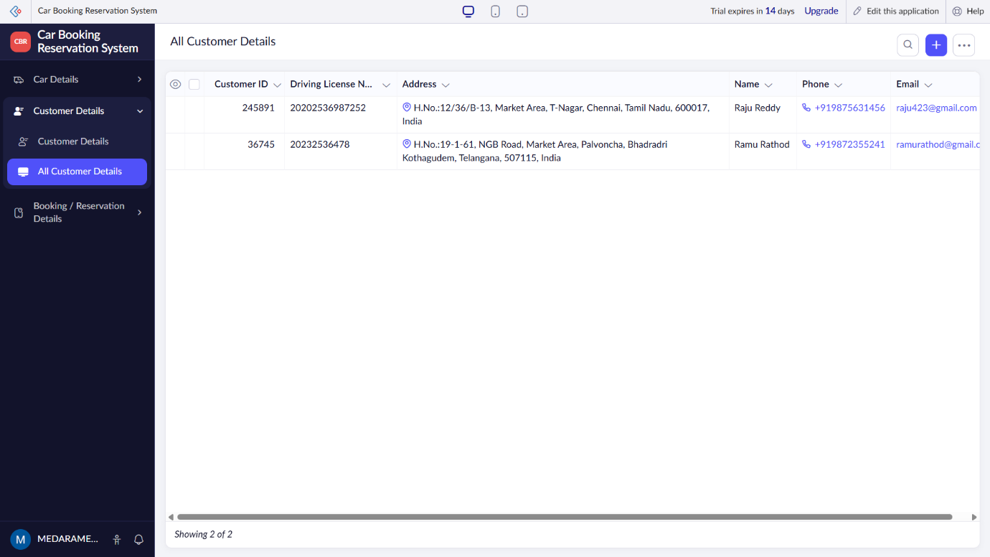

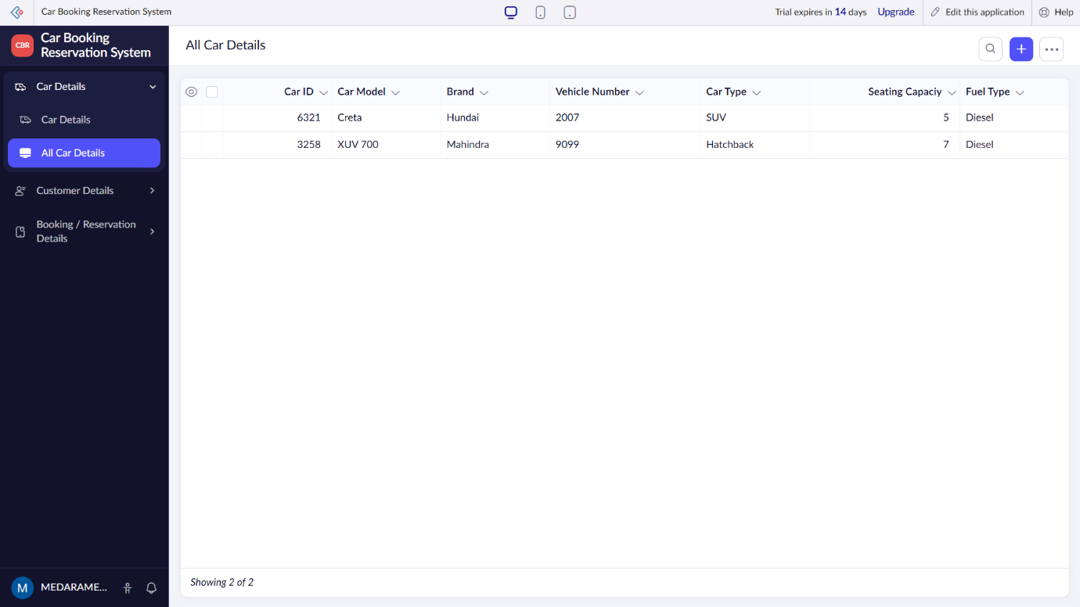
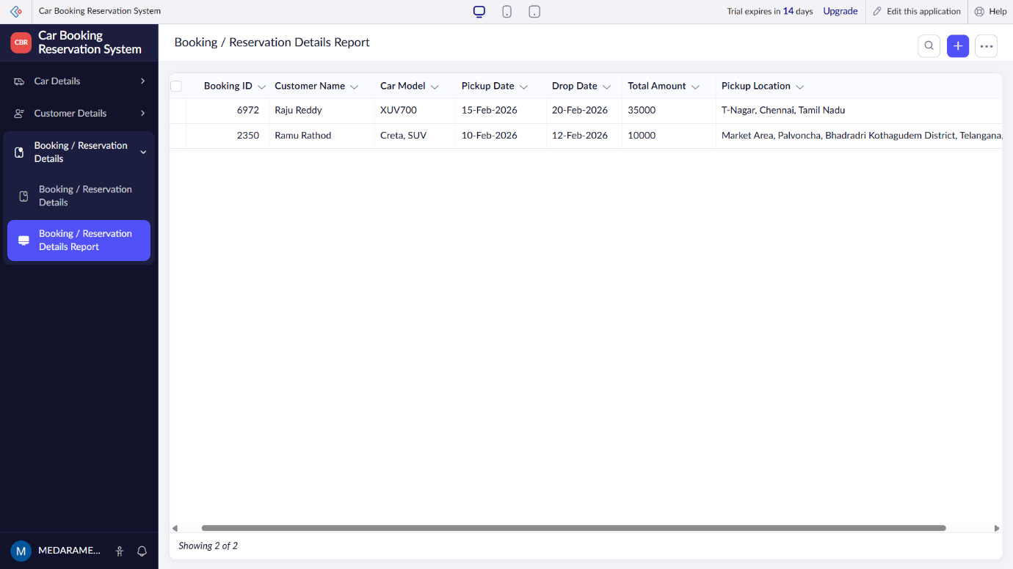

RESULT: A cloud-enabled Car Booking Reservation System is successfully created as a SaaS application, allowing users to reserve cars online.

